STUDENT CONFERENCE AWARD 2017
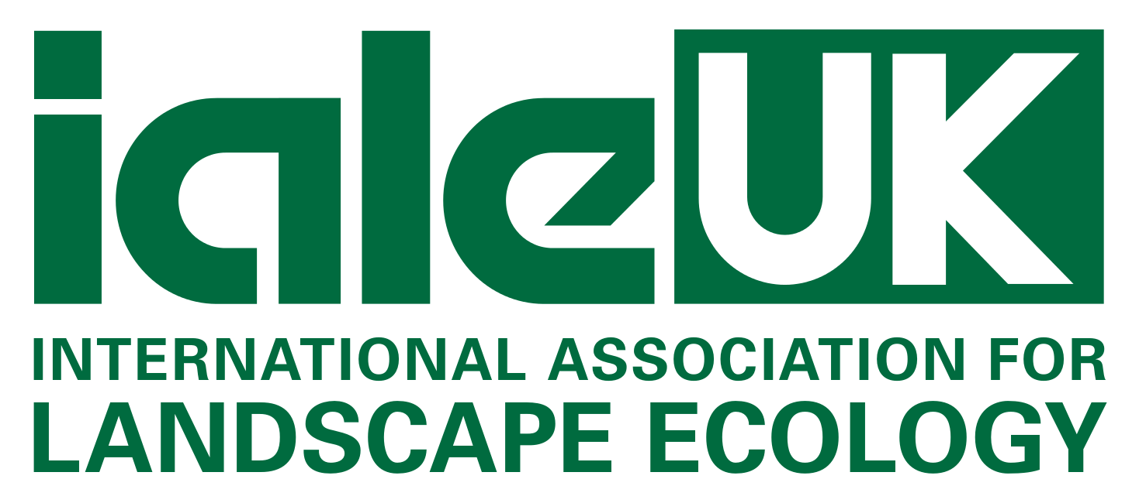

ialeUK welcomes Student Conference Award applications

for this year’s conference:

25 Years of Landscape Ecology
at Manchester Metropolitan University, 27 - 29 June

The Student Conference Award is designed to support students with attendance costs to ialeUK conferences. Applications are open to all students who are members of ialeUK. Please note that competition for the awards is usually high; however ialeUK will endeavor to support as many students as possible.
Full Name
University
Current level of study
Address
E-mail
Please briefly outline below why you would like to receive this award.

Please return your application via email to: students@iale.org.uk

Deadline for applications: TBC

Successful applicants will be notified by TBC
The lived environment

Mapping

