STUDENT CONFERENCE AWARD 2016
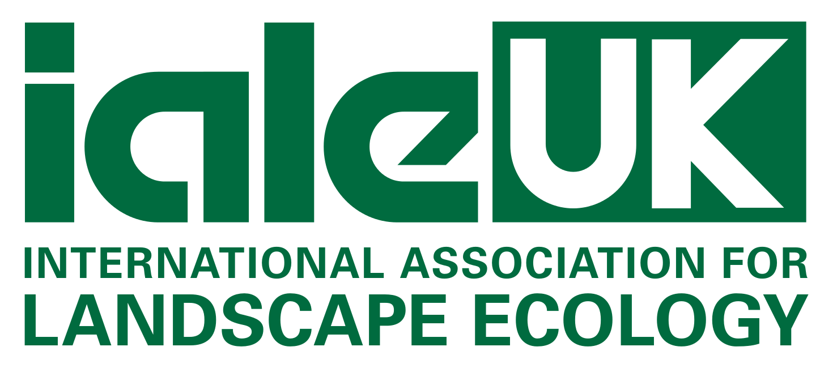

ialeUK welcomes Student Conference Award applications

for this year’s conference:

Landscape Characterisation
Methods & Applications in Landscape Ecology
at the University of Reading, 7th – 9th September

The Student Conference Award is designed to support students with attendance costs to ialeUK conferences. Applications are open to all students who are members of ialeUK. Please note that competition for the awards is usually high; however ialeUK will endeavor to support as many students as possible.
Full Name
University
Current level of study
Address
E-mail
Please briefly outline below why you would like to receive this award.

Total amount applied for in British Pounds (£):

Please return your application via email to: students@iale.org.uk

Deadline for applications: TBC

Successful applicants will be notified by TBC
The lived environment

Mapping

